Open Kross Challenges

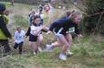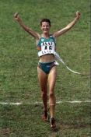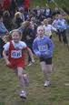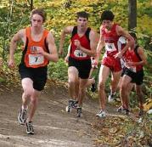

Cliffe Castle Park

Sat 14th Jan/Sat 11th Feb

9.45am

A simple format, easy-to-enter, low-key open cross country challenge that is all about participants of all standards challenging themselves and having the opportunity to run on a regular basis throughout the winter in a beautiful setting. Short, medium and long options - free to holders of school XC numbers!!

For details see www.kcac.co.uk

